US-German Research Proposal: Testing muscle synergies in a neuromechanical rat model for nominal and perturbed locomotion

CWRU: Roger D. Quinn (PI, Mechanical Engineering); Hillel J. Chiel (Co-PI, Biology/Neuroscience) Drexel: Ilya Rybak (Consultant, Dept. of Neurobiology and Anatomy, College of Medicine)

University of Jena: Martin S. Fischer (PI, Biology); Dirk Arnold (Physiology), Emanuel Andrada (Co-PI, Mechanical Engineering/Biomechanics); Eike Schomburg (Consultant, Neurophysiology)

# Introduction and Significance

One of the most impressive abilities of animal nervous systems is to quickly coordinate strategies outside their nominal patterns of behavior. In dynamic locomotion, we can observe real-time low-level problem-solving. Responding to perturbations such as unexpected ground height changes requires significant departures from nominal walking patterns, and these changes must be fast and coordinated in order to be effective. How are such responses generated in a dynamic neural hierarchy? How do higher- level networks dynamically interact with functioning low-level control networks to improve performance? How are dozens of muscles coordinated simultaneously? Are known pathways sufficient to explain the full range of behaviors for small and large perturbations? When the animal outperforms our model, what new mechanisms could explain observed behaviors? Addressing these issues will lead to a better understanding of how animals are able to quickly and effectively respond to their environments.

To understand the dynamics of hierarchical coordination in biological systems, high-fidelity biomechanical models are needed that accurately reflect the internal dynamics of the animal and its interaction with the physical world. The Quinn lab has experience abstracting components of neurobiological locomotion strategies (e.g. specific behavioral reactions, neural pathways, dynamic oscillators and organizational hierarchies) at tractable levels to validate these strategies in physical and software models [1]–[9], and further applying them in robots [10]–[18]. The Fischer lab experiments provide low-level behavior and performance data, e.g. joint kinematics, electromyograms of leg muscles and ground reaction forces, which are essential for validation and calibration of both mechanical and neurobiological models. In this work, we will combine insights gained from biological experiments in the Fischer lab with a dynamic model developed by the Quinn lab to explain novel behaviors. Our proposed collaboration will holistically test previous research from our labs and others, provide a foundation for addressing deeper questions in biology, neurobiology, and neuroscience, and inspire development of improved robotic control systems for dynamic control of walking and running.

To appreciate an animal’s skill in running, it is helpful to consider the state of the art in legged robots. Current legged machines like BigDog [19] and the 2013 WildCat can calculate slow, statically stable steps on rubble piles and stabilize themselves to run on relatively smooth ground. They are, however, unable to keep up with legged animals over arbitrary natural terrain. In contrast, animals exploit the mechanical advantages of multi-jointed legs by making small adjustments to muscle activation magnitudes and timing for stabilization– often without breaking stride. While these biologically-inspired reflexes can be abstracted as heuristics for robots, we also need biologically-plausible control structures to understand how different competing reflexes interact without overshoot or canceling each other out, how feedforward predictions of limited accuracy are combined with sensory measurements of limited precision, and how coordination of dozens of semi-redundant muscles is performed so that the entire system works together. Because these tasks are difficult for robots, robots are typically more cautious than animals, making them slower and more power demanding (i.e. heavier), and thus even harder to balance. In contrast, small animals adapt their stride based on the substrate and dynamically react to diminishing ground support, loss of traction, or contact with uneven surfaces. We hypothesize that the behavioral and EMG data during nominal and perturbed animal walking can be reproduced by small sets

of muscle activation patterns (synergies) that simplify the problem of coordinating the many leg muscles in real time. Accurate computational models of these phenomena will improve our understanding of mammalian spinal cord functional organization and inspire improved robots.

To better understand how the mammalian spinal cord processes multi-sensory feedback for dynamic control of many degrees of freedom in the hind legs, we will:

**Aim 1 – Conduct experiments examining 3D inverse dynamics and muscular activation in unperturbed and perturbed walking and running of rats.** We will collect data on three-dimensional kinematics, kinetics, and myogenic data of rat locomotion with dynamic perturbations. The data will be collected through simultaneous X-ray videography, force plates, and EMG recordings.

**Aim 2 – Expand our neuromechanical rat model to include 3D motions.** The model will combine previously investigated coordination pathways with a neural training method developed by our group to produce self-supporting forward walking of the hind legs in three dimensions.

**Aim 3 – Investigate mechanisms for control of synergistic muscle groups.** We will explore different organizational models and test the capability of these models for adapting to perturbations and maintaining dynamic control of walking behavior.

# Background

The anatomical hierarchy of the nervous system with the brain at the top and the motor neurons at the bottom has inspired many engineered control systems, however, the fact that engineered hierarchies cannot achieve the complexity and agility of animals suggests that there is much to learn from the functional organization of nervous systems. Examples of hierarchically modeled systems include humans [20], [21], other vertebrates [22], and insects [23], and learning tasks [24]. However, the nature of the hierarchical organization of the neural basis for behavior is debated [25]. Extensive modulation of reflexes by sensory inputs, the presence of both feedback and feedforward loops in the motor system, and the ability to flexibly change limb coordination might all suggest that neurobiological hierarchies can have complex multilevel interactions that are different than typical engineering hierarchies. The construction of neural systems in computational models can challenge and extend our understanding of the neural architectures that produce complex emergent behaviors.

Biological research has provided useful hypothetical control structures for different levels of this hierarchical control scheme. At the highest level, the brain forms decisions based upon internal context and external cues and sends descending commands to the local systems [26]–[29]. Intermediate oscillators (Central pattern generators or CPGs) produce self-sustained oscillations that coordinate behaviors [30]–

[35] with sensory feedback [36]–[40]. At low levels, afferent feedback modulates the strength and direction of movement [41]–[48]. Modeling has demonstrated the value of this type of hierarchy in insects [49]. The Quinn group has demonstrated that hierarchically descending signals from a low-parameter higher level can modify neurobiological oscillators and the sensory signals that entrain them to coordinate joints and legs into different gaits such that emergent kinematics matched observed cockroach data [1].

Rats rely on the dynamics and flexibility of their neurobiological coordination in ways that are more challenging than the requirements of insect models [1]. First, the wide stance and minimum of three legs on the ground during normal locomotion make the cockroach inherently stable [50]. Larger animals and robots walk with legs underneath the body to take advantage of better energetics; however, this more upright posture makes balance more difficult [51]. Second, insect muscles are highly damped, making inertial forces from the leg small compared to passive muscles forces, and requiring different control strategies than in mammals [52], [53]. The inclusion of passive muscle properties, and sensitivity to them, significantly affects the performance of robotic and modeled systems [10], [54], [55].

Recent modeling of mammalian nervous systems supports an organization in which coordinated patterns of muscle activation (muscle synergies) are driven by rhythm generators for each leg, which in

turn receive inputs from the brain [56]. Muscle synergies are consistent proportions of muscles’ activation that are reused for different tasks [57], [58]. In recorded muscle activations, such synergies have been found in many different walking systems including cats and humans [59]–[61]. These muscle recruitment patterns group muscles that apply forces in particular directions during balancing tasks and can be used to respond to task-level demands regardless of kinematic configuration. In posture control, synergistic muscle activations have been shown to be a function of time-delayed linear feedback of center of mass movement [62]. The degree to which this network is hierarchical or heterarchical, and the types of descending and ascending influences that occur, are highly debated. Our hypothesis is that muscle synergies provide a reduced parameterization that improves adaptation to the environment and perturbations when compared to a system in which all muscles are coordinated independently.

To understand dynamic walking strategies, we have used the literature and biological data collected by Fischer [63]–[66] and others [41], [67]–[70] to construct a control system that is able to coordinate stepping motions of a simulated rat built in AnimatLab [71]. This neurobiologically-based control system coordinates hind leg walking in the sagittal plane with an antagonistic pair of muscles for each joint. This model incorporates both physics-based mechanics and a detailed neural controller with a CPG for each opposing muscle group modified by afferent feedback [38], [56], [72]. We have also developed a method to train this neural system to produce robust, forward walking behavior in the hind legs [8]. The training method sets system parameters to produce desired motoneuron activation patterns based on expected muscular feedback.

This proposed work seeks to answer how complex muscular systems are effectively coordinated in adaptive walking. In particular, we will collect new 3D data from walking rats over a variety of conditions, expand our neuromechanical model of rat hind legs to locomote in a three dimensional world and explore how different neural organization schemes adapt to system perturbations and determine different failure mechanisms associated with each. We hypothesize that there is a set of synergistic muscle groups which will most closely match the animal behavior and EMG data for the proposed perturbation experiments on rats.

We have submitted proposals on this subject to this program previously. Since that time we have published papers that have addressed those previous reviewers’ concerns. We also appreciate the responses of previous reviewers who have suggested that modeling the full body might be too ambitious, while reducing motion to the sagittal plane might be oversimplifying. Focusing on the hind legs in 3D permits a high degree of accuracy while also providing the highest relevance to existing mammalian literature and biped walking. The reviewers also correctly recognized the challenge of training large dynamic networks. We have since developed an optimization method that allows us to match desired outputs with expected inputs and applied this method not only to a physics-based simulated rat but also to a robotic dog model [8], [18]. We are confident that the proposed 3D hind leg model will be relevant for improving our understanding of spinal cord circuits in nominal and perturbed locomotion.

# Results from Prior NSF support

RI: Medium: Dynamical Coordination and Sequencing of Multifunctionality in Animals and Robots (NSF IIS-1065489) $1,115,993, July 1, 2011 – June 30, 2016, PI: Quinn, co-PI: Chiel.

*Intellectual Merit:* With the support of NSF IIS-1065489, Quinn and Chiel are advancing and implementing stable heteroclinic channels (SHCs), a framework for designing networks of controllable dynamic oscillators, to model biology and control robots. We have shown that SHCs model sea slug swallowing better than traditional limit cycles [73]. To support our modeling efforts, we have identified interneurons [74] in semi-intact preparations [75] that recruit specific regions of the muscles to take turns pulling in food [76].

To make SHC networks accessible to a wide variety of applications, we have developed fast analytical approximations for directly specifying parameters based on desired waveform properties (e.g., mean total period, amplitude, stability, responsiveness, variability) [77]. We have shown how the mean period of SHC cycles can be modulated predictably by input noise [77] and how limit-cycle behavior can be generated by offsetting eigenvector directions [78]. This work is the basis of an open source toolbox

[79] that has been successfully applied to specific problems in robots [7], [80], [81].

*Prior Broader Impacts – Societal Impact:* Our animal-inspired soft robot controlled by SHCs could navigate tight spaces like gas/oil/water pipes, collapsed tunnels and might someday be scaled down for endoscopy and as stents in places that cannot be reached with current medical practice. We have patents on key inventions and interested parties are contacting us about commercialization and rapid-prototyping.

*Prior Broader Impacts – Professional Impact:* 33 publications and four Ph.D. degrees have so far resulted from this prior NSF support. Our first softworm robot prototype won the IEEE ICRA “Best Video” award [82] and we demonstrated it publicly in London at the Living Machines conference [83], and at university research showcases [84], [85] . Chiel’s work in soft-bodied animals has resulted in biomechanical models and neural mechanisms that enabled this work.

*Prior Broader Impacts – Outreach K-16:* Over the course of our project, we have provided lab tours for hundreds of people and demonstrations at local elementary and high schools, for First Robotics Groups, and for a university intellectual property board including successful entrepreneurs. The group gave well-attended demonstrations at the Great Lakes Science Center, the Jefferson Society in Erie, and Cleveland’s Ingenuity Festival, introducing students of all ages to the exciting field of robotics. Every summer, we have had one to three high school students, including some from inner city schools, work in our labs for extended periods. At least two of these students are now studying engineering in college with an emphasis on robotics. We are a host lab for a First Robotics Group at the Hathaway-Brown Prep School for Girls. We have given presentations as part of Project ¿QUÉ? for Latino middle schoolers. We have mentored numerous undergraduate researchers in our labs including five female students (one African American) through REU supplements during the past two summers, one of whom is now in graduate school. One of our robots was featured in a university promotional video highlighting three women in research. See below to see how our NSF funded work has otherwise influenced our outreach and teaching and our plan to continue and expand those efforts.

# Research Strategy

## Aim 1 – Conduct experiments examining 3D- joint control: muscular activation and 3D inverse dynamics in unperturbed and perturbed walking and running of rats. (Years 1-3)

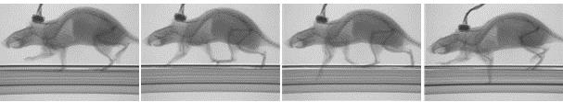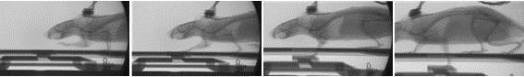

**Figure 1 – Stills from X-ray movies. Top: rat stepping into a hole on perforated belt. Bottom: rat stepping on a trap door, which is released in frame 3.**

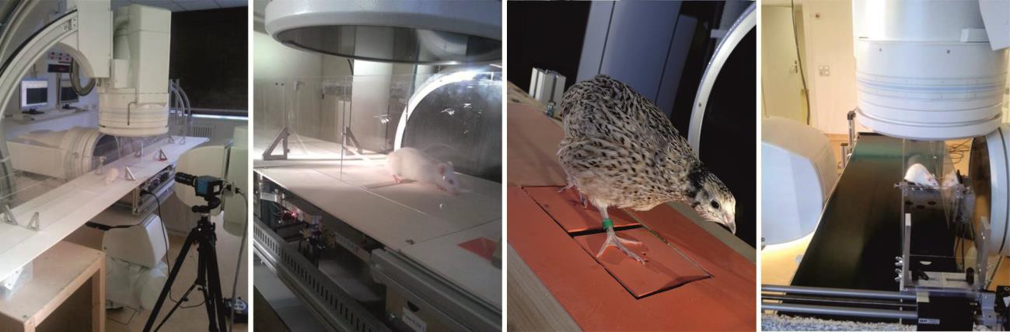

**A B C D**

**Figure 2 – Rat #1 from group #1 running along the walkway with X-ray system ready to record the control data from the steady-state (A) as well as the perturbed data from the trap door (B) and a randomly perforated belt (D). (C) Quail stepping on carbon fiber-made force plates. These plates allow synchronous biplanar X-ray and force recording.**

To accomplish this task, we propose to first collect data of three-dimensional kinetics and kinematic motions of rat locomotion. Kinematic data will be collected through X-ray videography (Fig. 1) and ground reaction forces will be collected using available custom-build force plates ([86], [87]. This will increase our understanding of the joint dynamics of rats in three dimensions. We have chosen rats as the experimental subject because their size makes them excellent for studying full body kinematics in front of the 3-D X-ray machines. Moreover, they are easy to handle and train, and are robust against infections and heal quickly after the experimental procedures. Though forward locomotion is often observed as a planar phenomenon, it is evident that corrective reactions out of the sagittal plane, though small in comparison, play an important role in maintaining stability during locomotion. The collection of 3-D kinematic data is particularly critical in small species with their highly flexed and abducted limbs. This kinematic and kinetic data of the animal will add to the available two dimensional data [65], [66], [88]**.**

Along with kinematic and kinetic data, myogenic information will also be collected to understand muscle timing and activation patterns. Muscles have inherent dynamics and when the nervous system calls on a muscle to activate, desired tension levels are not reached instantaneously and tension builds over time. Depending on the level of activation, the configuration of the muscle, muscle strength, and the inertia of the limb the muscle is acting on, the visible changes in motion are delayed. Because of this, EMG recordings present more reliable knowledge of timing in the control structure than kinematic motions.

The Fischer lab is well equipped with state-of-the-art instrumentation to perform the proposed animal experiments (Fig. 2). Not only does this system allow for full 3D kinematic motion observation, it does so at frequencies up to 2000 Hz with high resolution (1536:1024), enabling us to record movements precisely and theorize which corrective movements occur at the spinal level without influence from supra spinal circuitry (shorter time scales), and which reactions may require additional processing from outside the spinal cord (longer time scales). Preliminary results show that reactions to instability of elbow- or knee-deep holes during treadmill running occurs within 2 ms – far faster than any supra spinal control possibilities and thus indicative of local reflex control strategies.

The design of these studies also makes it possible to compare the muscle activities of both body sides and reveal the inter-limb coordination as well as full body dynamics and energetics. In preliminary work, EMG activity of the biceps brachii and the triceps brachii muscles on both body sides were recorded.

Proposed experiments will include additional recordings from major hind limb muscles (M. glutaeus superficialis, M. biceps femoris, M. quadriceps femoris). Two single electrodes are implanted in each muscle at two different locations. The recorded monopolar signals are subsequently bipolar corrected.

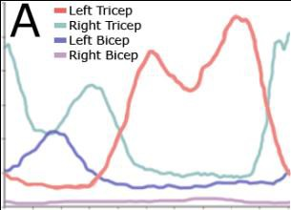 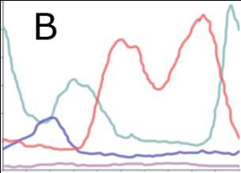 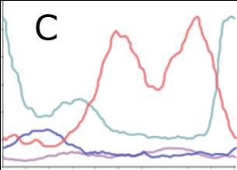 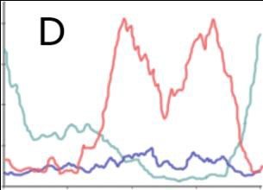

Stance Right

|  |  |  |  |  |  |  |
| --- | --- | --- | --- | --- | --- | --- |
| Stance Left |  | Stance Left |  | Stance Left |  | Stance Left |
|  |  |  |  |  |  |  |
| **Figure 3 – Average EMG in one stride cycle of normal locomotion of a rat on a (A) non-compliant belt, (B) medium**  **compliant belt, (C) highly compliant belt, and (D) belt with holes.** | | | | | | |

Stance Right

Stance Right

Stance Right

Simultaneous recordings of the ground reaction forces (GRF) during walkway locomotion in combination with EMG and biplanar high-speed X-ray videography will help determine the mechanisms of leg and trunk compliance. Similar experiments have been used to reveal the specific locomotor forces acting on the trunk during locomotion in the dog [89].

To examine the control mechanisms and elucidate intra-limb and inter-limb coordination within rats, we have developed four experimental setups that include single-limb and full body perturbations while the animal is locomoting. The first setup consists of a treadmill with different belt compliances run at different speeds. In the second setup, the treadmill is equipped with a randomly perforated belt to study cyclic walking and non-cyclic perturbed locomotion (Fig. 2D). The third setup consists of a walkway equipped with a trapdoor (Fig. 2B). The integrated force plate records ground reaction forces and releases the door during stance at a pre-selected force threshold. The trapdoor can be activated before or after reaching the maximal GRF. The fourth setup consists of an instrumented walkway, in which custom- made force plates (Fig. 2C) are located at different heights. We aim here to combine 3D-inverse dynamics with EMG data recordings. Implanted markers will be used to reconstruct the position in space of each extremity segment.

Each setup is designed to record information under unique conditions. In treadmill experiments, ground contact is softer or postponed, whereas in trapdoor experiments initial touchdown time is not affected. The first experiment mimics walking over different types of ground, from hard packed dirt to that of a trampoline. The second experiment is comparable to stepping into an unseen hole and the third simulates breaking through unstable ground. The fourth experiment simulates uneven locomotion. When terrain is uneven or unpredictable, gaits become more variable and energy costs increase [90]. We aim to separate anticipatory (feedforward) from reactionary (feedback) mechanisms, hypothesizing that anticipatory control of trajectories may allow animals to minimize muscular effort, as suggested by recent bipedal simulation studies [91], [92]. Each of these experiments will generate unique reactions from the neuromechanical system.

In preliminary work, four animals were measured on the first three setups at 0.5 m/s. The activity of the biceps and the triceps brachii muscles of both forelegs were recorded with platinum–iridium EMG electrodes synchronously with X-ray and high-speed video. Approximately 400 steps were analyzed for hard, medium, and soft substrates, 40 steps into holes on the perforated belt, and 40 steps on the trapdoor.

Analysis has revealed that in all experiments the triceps and biceps brachii muscles on both sides were reciprocally activated. Furthermore, the activation of the triceps started within the last third of the contralateral stance phase, resulting in co-activation of the two sides (Fig. 3).

Compared to the hard substrate, the overall activation patterns were similar while the rat ran on the medium and soft substrates (Fig. 3A – C). Differences occur in terms of decreased activation of the second maximum of the right triceps brachii muscle and in the left biceps muscle. We do not know the reason for this asymmetry; however, it is possible that the handedness of the rats plays an important role. Rats will be examined for handedness before future experimentation, and if results indicate differences,

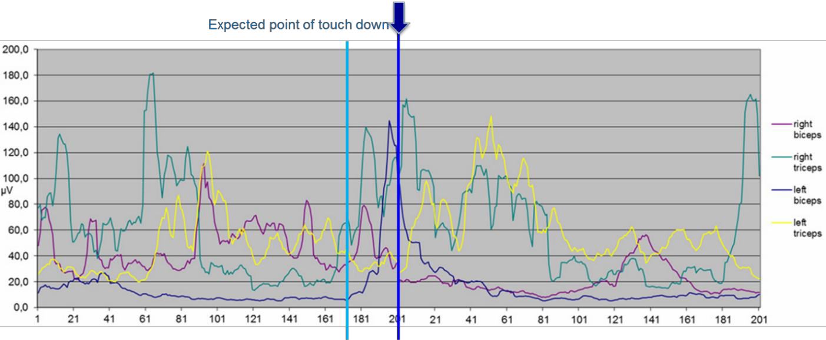

**Figure 4 – EMG of fore limb muscles. As a rat steps into a hole with its right forelimb (light blue bar), the right triceps (teal trace) activates in anticipation of ground contact. When no contact is made, the left biceps (blue trace) activates to facilitate lower, later ground contact (dark blue bar).**

we will categorize the data accordingly. In all experiments, the bicep muscle was activated during the contralateral stance phase to bend the elbow joint of the ipsilateral limb within the first half of the swing phase. The activity stops before the contralateral biceps is activated except on the highly compliant belt. It is observed that the biceps brachii muscles were not normally co-activated; however, with the compliant belt, there is some overlap. This co-activation may represent a stiffening of the biomechanical system in response to decreased stiffness of the substrate, similar to what has been recorded in human locomotion [93]–[95].

A comparison between muscle recruitment patterns while running on a compliant substrate and on the perforated belt shows similar recruitment patterns. The belt with holes is more compliant than the stiff belt because of the perforation, and activation is most similar to the softer belts. Additionally, despite not being able to see the holes, the animal seems able to anticipate their arrival, and the similar activation patterns may be an increase in stiffness due to anticipation of the perturbation [96].

When the rat did step into a hole, distinct differences in the muscle activity occurred as compared to the other experiments (Fig. 4). While initial activity of the ipsilateral triceps brachii muscle was not affected by the postponed ground contact, the duration of the triceps brachii muscle activity increased. A strong co-activation of both triceps muscles occurs after the touch down. In the time between the expected and the postponed ground contact, a strong reaction of the contralateral biceps muscles was observed. The contralateral forelimb is notably more flexed than normal and the center of mass lowers. On the other

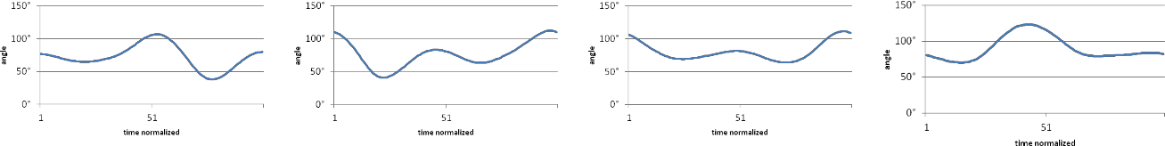A1 A2 A3 A4

B1 B2 B3 B4

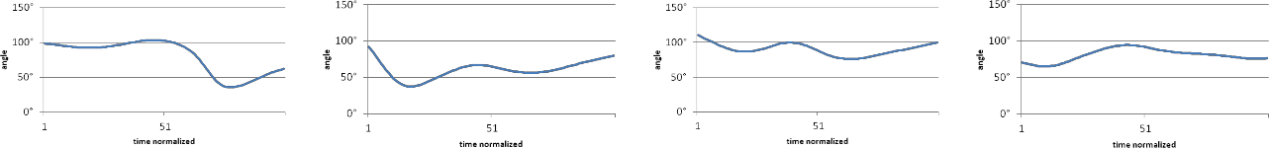

**Figure 5 – Kinematics of the right and left elbow and shoulder joints. A) Unperturbed locomotion. B) The rat stepped into a hole with the right fore limb, 1) right elbow joint 2) left elbow joint 3) right shoulder joint 4) left shoulder joint**

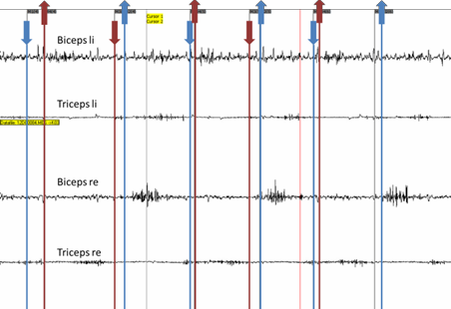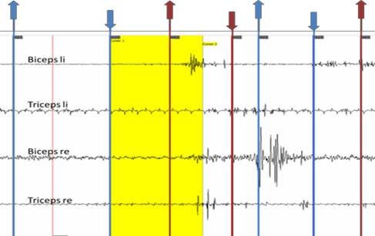

**Figure 6 – Raw EMG data of the right forelimb during normal trot (left), and touchdown on the trapdoor with right**

**forelimb (right) over time. The yellow bar indicates the duration from the touchdown on the trapdoor to the deepest point. The blue arrows show touchdown and lift off of the right forelimb and the red arrows show this for the left forelimb. Different muscle activities are stacked along the y-axis. From top to bottom, they are left biceps brachii muscle, left triceps brachii, right biceps, and right triceps.**

side, the biceps muscle was more highly activated to bring the contralateral limb up and in front as fast as possible. The activation starts between 5 ms and 50 ms after the expected contact. In addition, earlier, stronger and prolonged activity can be observed for the contralateral triceps muscle during touchdown of its foreleg, causing a co-activation of triceps activities. These suggest an additional control mechanism that reacts to the perturbation as the observed response is not passive. Initial kinematic results (Fig. 5) reveal that the shoulder and the elbow joint of the forelimb that stepped into the hole are more extended than in undisturbed locomotion because of the delayed ground contact. These results matched with the EMG data in which the triceps muscle is longer and more strongly activated. Additionally, the joints of the contralateral side are more flexed than during normal locomotion.

Differences in the activation patterns occurred if the animal stepped on the trapdoor as shown in Fig. 6. After the foot touches down on the trapdoor, the trapdoor is actuated and both trapdoor and foot reach the bottom of the well in approximately 140ms. All muscle activations are increased. A co- activation of both biceps muscles as well as the ipsilateral triceps muscle can also be observed. Both

A B

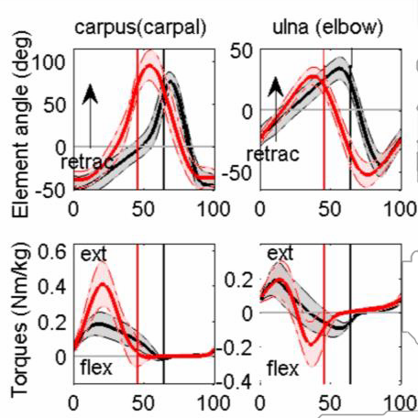 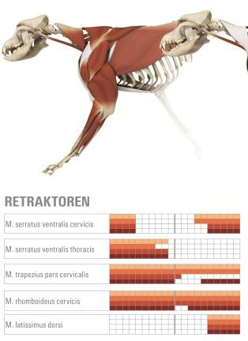

**Figure 7. Kinematic, torque, and EMG data collected of dogs in the Fischer lab. A. Mean and s.d. curves of segmental angle and torque about the lateral axis of 5 clinically normal adult beagles for a stride-cycle (trot, n = 140 strides; walking, n = 89 strides). 0 and 100 indicate touch-down and the vertical solid lines indicate Toe-off. B. Muscle activity of five muscles in the thoracic leg of a dog during walk and trot** [101]**.**

muscles of the contralateral side are more strongly activated. There is a large delay in the lifting of the contralateral forelimb when compared to a normal run. Our results clearly show information transfer between limbs of the same girdle, which confirm previous results in cats [97],

[98] and humans [99], [100].

We will build upon this preliminary work by collecting statistically meaningful data of the hind legs through further experimentation using all four specified apparatuses and more animals. These rat data will be compared with experiments currently being conducted on dog limb joints in

Fischer’s lab. These dog experiments combine XROMM, infrared systems, and instrumented quad- treadmills to analyze gait and body construction related differences in 3D dog joint mechanics. To date, four breeds have been analyzed: Beagles, Whippets, French Bulldogs, Malinois. Figure 7 introduces unpublished results on thoracic leg about the lateral axis for walking and trotting beagles.

The collected rat data will be also be compared and contrasted with published data for other animals of similar structure such as dogs [89], [101] and bipedal animals such as ostriches [102], northern lapwings [103], quails [86], [87] and humans [104], as well as with arthropods [105]. Additionally, template related (e.g. SLIP models [87], [106], [107] and joint related strategies for negotiating rough terrain will be compared and contrasted with data collected for other animals such as birds [91], [108]–

[110] and humans [111]–[114].

These data and comparisons will serve to inform the continued expansion and improvement of our existing neural control system similar to recent publications from our labs. In our preliminary work, intra- leg and inter-leg coordination pathways are derived from behavioral experiments, kinematic data, and dynamic data [3], [9], and a neural system was successfully trained to produce forward walking in a physics-based simulation of rat hind-legs using 2D- inverse dynamic data from the rat [8], [88]

## Aim 2 – Expand our neuromechanical rat model to include 3D motions. (Year 1)

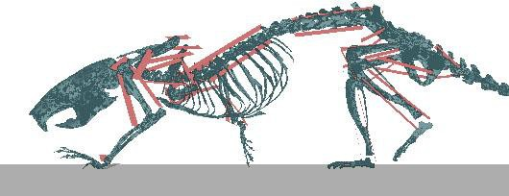Neuromechanical modeling of the hind legs walking in 3D will help us understand how the neural system can stabilize forward locomotion. The neural circuits that control animals’ legs depend on dynamic rhythm generators that are responsive to sensory input. Experimental literature provides evidence of particular sensory pathways, which we have used to demonstrate

**Figure 8 – 3-D model of a rat skeleton** [115] **modeled in**

**AnimatLab** [71]**, constrained to the sagittal plane. Simulated muscles are shown in red. Physics are simulated by the Bullet engine** [116]**.**

coordinated walking in our previous rat simulations [3], [9] in AnimatLab [71] (Fig. 8). Although the phase was appropriate for a trotting gait, the kinematics and ground reaction forces did not match the animal data.

To match the animal data, we have developed a method for training a neural system to produce self- supporting walking which has successfully been applied to the transverse rotations in the hind legs of the rat model. In other words, we demonstrated the ability to tune the parameters within hypothesized dynamic neural architectures to demonstrate walking with hinges that allow sagittal plane motion at the hip, knee, and ankle.

Because the crouched posture of a rat produces significant motions out of this plane which can only be captured by a 3D model, we will our expand our neuromechanical model to include additional degrees of freedom: hip abduction/adduction, hip external/internal rotation, ankle axial rotation, and ankle inversion/eversion. The inclusion of these joints will allow us to model laterally stabilizing motions and determine how muscles controlling these motions are influenced by the central pattern generators and sensory feedback timing. These additional joints will be activated using antagonistic muscles isolated to the particular motion of interest but more complex and actuate muscles will be added as needed in Aim 3.

Aim 2 work will demonstrate that our approach for matching force data is scalable to more DOF (7 instead of 3) and will allow testing of architecture designs under 3D perturbations.

### Calculating Desired Motoneuron Activity

The first step in building a new expanded model will be to calculate the desired motoneuron activity from recorded kinematics and force plate data as follows:

Kinematic and  Joint  Muscle  Motoneuron

Force Plate Data Torques Tensions Activations

Joint Torques are calculated using inverse dynamics [115]. Internal forces of the joints and net torques about the center of mass (CoM) of limbs and body-stem segments are estimated by applying the Newton–Eulerian approach. Muscle tensions required to produce these motions in the model can be calculated from the joint torques with the moment arm calculated from kinematics and the physics-based model. In Aim 2 these solutions are unique because of the assumption that only one muscle per joint actively contracts at any time [117].

The muscle model is based on the linear Hill muscle mode, for which tension is produced according

to:

*dT*  *kse*  *k x*  *bx*  1 *kpe*  *T*  *A*





*dt b* **** *pe*



*k*

****

 

 *se*  

where *x* is the muscle length, *kse* and *kpe* are the series and parallel stiffness, *b* is the damping element,

and *A* is the activation. Muscle length ( *x* ) and muscle velocity ( *x* ) can be calculated using model geometry and kinematic data. First, the passive forces are calculated as the muscle force when *x* is cycled

as with normal locomotion and with

*A* (the activation level)  0 . The active muscle must provide the

previously calculated tensions for joint torques as well as overcome torques created by the passive forces produced in each muscle. Thus, tension *T* of the active muscle can be determined and numerically differentiated to determine the activation magnitude *A* of the active muscle as a function of time.

### Modeling and Training the Neural System

The next step is training the connection strengths of hypothetical architectures to produce these motoneuron activations from expected sensory inputs.

The largest sensory influences are from proprioceptive feedback from joints within the same leg.

These inputs are so important that for many animals, legs are able to make reliable steady-state stepping motions even when connections to the brain are severed [118], [119]. Muscle force is produced by a combination of feedforward control from CPGs that are influenced by sensory feedback, as well as up to 30% direct feedback control of muscle afferents [120].

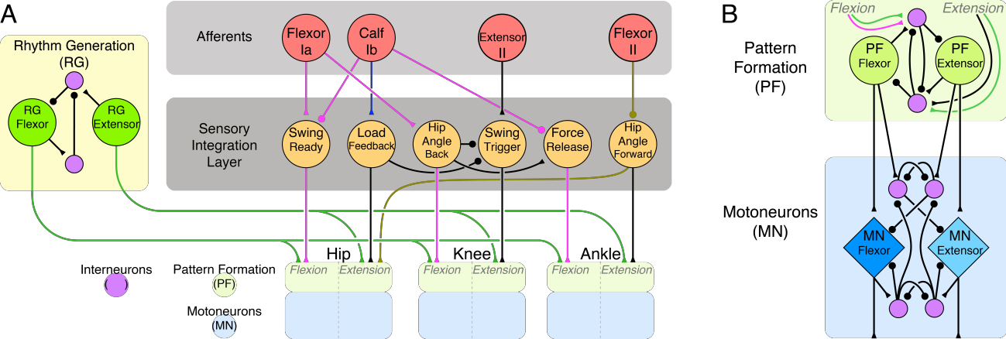Sensory feedback in our leg controller models consists of different types of muscle proprioception, e.g., stretch receptors, muscle afferent feedback, ground contact and force sensing. We utilize three types

**Figure 9 – Coordination network for rotation in the sagittal plan of the hip, knee and ankle of the rear rat legs with proposed addition of the leg level Rhythm Generating (RG) network. (A) Sensory feedback (red circles) is filtered (orange circles) and used to coordinate the pattern formation (PF) networks. Leg CPGs consist of a shared rhythm generation circuit (green circles,** [56]**) and pattern formation layers at each joint. Coordinating pathways are inhibitory (filled circles) or excitatory (filled triangles). Pathways inspired by biological research are indicated by colored synapses of magenta** [68]**, blue** [41]**, and brown** [69]**. Hypothesized pathways are in black. (B) Detail of pattern formation and motor neuron circuitry for each joint** [38]**.**

of muscle afferent feedback (Ia, Ib, and II) [121]. Type Ib feedback is dependent on load receptors and can be calculated by load on a joint for a motor driven system. Type II feedback is dependent on stretch receptors in muscles and can be approximated by the length of the parallel element in the Hill model (90% of total resting length). Type Ia feedback is the most complicated and includes elements of muscle length and muscle velocity, and can be approximated by the length of the series element in the Hill model. Sensory information causes graded changes in thresholds based on the level of sensory feedback. Often, sensory feedback is filtered before modulating the CPGs in the spinal cord. Combinations of sensory signals are sometimes required to elicit a CPG phase transition [48], [122], [123], and several have been implemented in our networks so far. The way that these sensory inputs are connected to our model [8] are directly adapted from rules in mammalian literature. For example, the stance-to-swing transition that occurs from both a reduction in firing in Ib Golgi tendon organ afferents, and increased firing from hip flexor stretching [68] is incorporated into the model (Fig. 9A, magenta connections). Other control paths based on animal experiments [41], [69] are shown in Fig. 9A. We have shown that these paths, as well as others (shown in black), with a detailed study of 2-D kinematic and dynamic data [63], [65], [66] are capable of coordinating hind leg joints similarly to that of the walking animal on flat ground [3], [9] and on a treadmill running at various speeds [18].

However, walking is not merely reactive, it is a purposeful motion driven by rhythm generators that receive inputs from the brain [56]. Rhythm generating CPGs within the spinal cord may modulate the speed or assist in transitions when sensory inputs are missing. These CPGs influence pattern formation layers in conjunction with direct sensory feedback [38]. Sensory feedback appears to be more important for distal joints than proximal joints [124]. With the help of our collaborator Dr. Rybak, we will update our current neural model to include a CPG for each leg which modifies the pattern formation layers below it similar to recent work (Markin 2015 in press).

The network structure for combining sensory-feedback (reactionary responses) and rhythmic motion (anticipatory responses) includes half center oscillators (Top of Fig 9B). Pattern formation is implemented as a four-neuron half-center oscillator. Two neurons, the pattern formers, are based on the Morris-Lecar model [125]. Their dynamics are described by the differential equations:

𝐶 𝑑𝑉 = 𝐺(𝐸𝑟𝑒𝑠𝑡 − 𝑉) + ∑𝐺𝑠𝑦𝑛(𝐸𝑠𝑦𝑛 − 𝑉) + 𝐺𝑁𝑎(𝐸𝑁𝑎 − 𝑉) ⋅ 𝑚 ⋅ ℎ

𝑑𝑡

𝑑𝑚 = 𝑚∞ − 𝑚 , 𝑑ℎ = ℎ∞ − ℎ

𝑑𝑡

𝜏𝑚

𝑑𝑡

𝜏ℎ

Where *V* is the membrane voltage of the neuron, *C* is the membrane capacitance, 𝐺(𝐸𝑟𝑒𝑠𝑡 − 𝑉) is the leak current, 𝐺𝑠𝑦𝑛(𝐸𝑠𝑦𝑛 − 𝑉) are currents due to synaptic connections, and 𝐺𝑁𝑎(𝐸𝑁𝑎 − 𝑉) is a persistent sodium current with voltage dependent channel activation and inactivation described by *m* and *h*.

The rest of the neurons in the network serve as interneurons and are governed by the same voltage

equation but with *GNa* set to 0. The full pattern formation network for each joint has 10 neurons, 20 synapses, eight inputs, and two outputs, resulting in hundreds of manipulable parameters. Behavior can vary widely as they are adjusted.

To set these parameters to match the animal motions and forces, the optimization tool divides the problem into tractable components based on system function and trains each components before adding more detail. Training of each subgroup starts with a genetic algorithm to obtain a wide sampling of the parameter space and search for a solution that is near the desired result. A genetic algorithm is appropriate, because there can be many different local minima within biologically plausible bounds. After the exploration by the genetic algorithm, best fits are refined with a gradient-less serial exploitative method, e.g., Nelder-Mead simplex [126]. Fig. 10 shows an example of motoneuron output from the rhythm generation circuit (see Fig. 9) compared to the calculated motoneuron output required to generate the rat’s motion. Optimizing the individual pattern formation networks not only makes the construction of

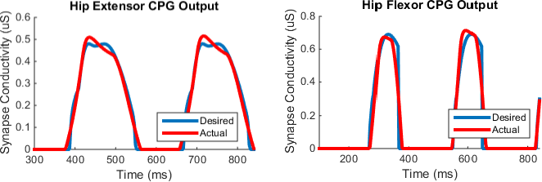

**Figure 10 – Rhythm generation circuit parameters are optimized to produce a desired output signal. Given afferent input calculated from rat motion and required motor neuron activations, the 20 most sensitive parameters were obtained from our optimization procedure.**

larger systems more tractable, but also strengthens the validity of the model and the performance results. We are able to train the pattern formation networks of a single joint in approximately 1 hour on a PC.

We will expand our current model which is able to walk in the sagittal plane to one that performs self-stabilizing walking in three dimensions with the described method applied to the new joint rotations. Each rotation will be isolated (e.g. three concurrent hinge joint vs one ball and socket joint), and the movements over a nominal step cycle will be analyzed. This analysis will inform the connectivity of the sensory system onto the pattern formation layer, and the synapse parameters of the individual rotation network will be trained to produce the necessary motoneuron activations for steady state walking. To evaluate this model, we will test the hind legs in AnimatLab by comparing the resultant kinematics to the animal data. We will also test the ability of this model to adapt to similar perturbation experiments to those performed on the animal.

## Aim 3 – Investigate mechanisms for control of synergistic muscle groups. (Year 2-3)

To test our hypothesis that the behavioral and EMG data during nominal and perturbed animal walking can be reproduced by small sets of muscle activation patterns (synergies) that simplify the problem of coordinating the many leg muscles in real time, we will first calculate effective EMGs, analyze the resulting synergies, then implement them in our neural controller and evaluate performance.

### Using a Neuromechanical Model to Determine Effective EMGs (Modeled Motoneuron Activations)

In order to study muscle synergies in the hind leg of the rat, we will increase the complexity of our model to more accurately reflect the animal’s biomechanics. We will do this by increasing the number of muscles in the model of Aim 2 from 7 pairs of antagonistic muscles to 23 muscles per leg. This model will have multiple muscles per degree of freedom and include biarticular muscles that span multiple joints. The attachment points, moment arms, and properties for each are well defined [127]–[129]. With a more accurate biomechanical model, we can both test the use of synergies for effective control and more directly use the animal data collected (Aim 1).

Typically, synergies are determined from measured muscle activations, however, with insufficient recorded EMG data, motoneuron activations can be estimated from the force and video data (described in aim 2). Because of the redundancy in the actuation system in this more accurate model (23 actuators compared to 7 degrees of freedom), there is no longer a unique solution which will give us the desired torques and motions, so instead we will employ minimum-effort control (sum of the squared normalized motoneuron activations). Minimum-effort control is a method that has been found to accurately predict and model motoneuron activations for many other experimental procedures [130]–[133]. Because this process is very computationally expensive for such a large number of degrees of freedom, it will be performed on the CWRU high performance computing cluster. These probable motor neuron activations

can be thought of as effective EMGs for animals performing the tasks in Aim 1. We will refer to these data as MMNAs (Modeled Motoneuron Activations). The MMNAs will be compared with our limited experimentally measured EMG data and the resultant activation profiles will be adjusted if necessary. This method allows us to generate more data for determining synergies than would otherwise be possible.

### Analyze the Calculated Modeled Motoneuron Activations for Synergies

From these MMNAs, we will look for evidence of synergies. Assuming linear combinations, we can find muscle synergies by performing matrix factorization with principal component analysis or using improved alternate methods that have been proposed in previous studies [134]–[136]. Even though the individual rats may have small variations in EMG-determined synergies (as has been found in other animals particularly in activity levels), because all of the MMNA-determined synergies share the same physical model, we expect less variability in MMNA-determined synergies.

We expect our results from nominal walking behaviors will be similar to previously calculated synergies in humans, cats, rats, and guineafowl [137], walking and perturbed walking in humans [138], and postural control in cats [135], [139]. We will test if adaptations to our Aim 1 experiments can be explained with these nominal synergies. Additionally, we will analyze the perturbation experiments for synergies that specifically facilitate responses to system perturbation. Experiments such as walking over uneven ground or ground with different stiffnesses may reveal new or modified synergies which enable the rat to adapt to these situations with little control effort.

### Look for Functional Significances of Particular Synergies

To adapt to changes in ground stiffness, missed footfalls, unstable ground, and changes in speed in the experiments in Aim 1, we will look for task level synergies. The most basic type of synergies we expect to find will be correlated with stance and swing timing [14], [67], [68], [140]–[143]. However, these motions will have to be altered to maintain balance and stability, perhaps with other synergies. In particular, one such synergy relationship we will look for is one that changes leg stiffness [93]–[96].

Changes in joint stiffness may occur in walking on substrates of differing compliance, e.g., the treadmill belts of different compliance in Aim 1. Additionally, an active change in leg stiffness may be a strategy deployed after delayed ground contact (as when the rat steps in a hole in Aim 1). Stick insects [144], [145], and cockroaches [146] passively increase joint stiffness as a function of speed, because their muscles do not have enough time to relax to zero tension. This rejects some perturbations without additional energy expenditure by the animal [52]. Our model can help find such synergy activation since muscle tension is difficult to measure in a moving animal.

Other relationships we will look for are synergy activations which correlate with changes in angular and linear momentum [147]–[151], and body posture [42], [152], [153]. Further analysis of the animal data may reveal new factors for maintaining stability, or may show that some of the proposed factors are not significant in the observed scenarios.

### Model Synergies in Neural Architecture

We will then expand our neural model to include these synergistic activations and test whether they are sufficient for explaining the behavior of the animal and maintaining stability in the model while undergoing perturbations.

Expansion of the model will be performed by improving the modularity of the system (Fig. 11).

Instead of pattern formation (PF) layers innervating single motoneurons (as in Aim 2), a half-center can innervate any number of motoneurons in a particular synergy (from none for an inactive phase of the PF to all 23 muscles perhaps to stiffen the entire muscular system) (Fig 11B). The number of pattern formation levels could vary in complexity and number as needed (Fig 11A). Afferent feedback will become more generalized in some cases, such that the sensory integration layer could encode factors such as stiffness, momentum, and body posture parameters that might be determined from multiple

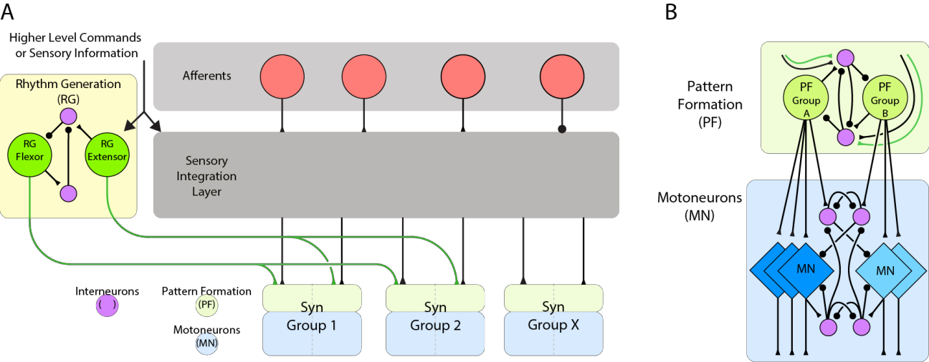

**Figure 11 – Neural model modified to include synergy activations. A. Higher level commands or sensory information that encodes for things such as desired stiffness or linear momentum can be used to influence the RG and Sensory Integration Layers. B. Pattern formation units are then used to activate specific synergies instead of single motoneurons.**

proprioceptive inputs. Although the animal might not measure these factors precisely, neurons have been found whose activity correlate strongly with speed [147], turning velocity [154], body pitch [155], and angular movement [156], several of which are known to activate before the behavior occurs. Additionally, synergies need not be innervated by the RG portion of the CPG if the synergy is not found to be correlated with a particular phase of the step cycle.

Implementing the synergies in our neuromechanical model allow a thorough evaluation of their effectiveness, appropriateness in matching the data and complexity. To compare with this model, we will also implement controllers in which each joint is controlled independently (no synergistic coupling) as well as a model in which all muscles have been included in a two-synergy model of stance and swing.

Our belief is that the organization of the animals’ musculature allows for the inclusion of synergies which are centered around task-level goals such as stiffness or linear momentum control. This modularity simplifies the control problem in the animal, allowing for easier corrections to perturbations and adaptations to the environment. By simplifying the control of these important tasks, more dynamic and adaptive movements can be created over a wide range of behaviors. Our testing of different neural organization schemes for the basis of synergies will help reveal adaptations which have proven useful to the development mammalian walking systems.

# Broader Impacts of Proposed Research

*Intellectual and societal impact*: The proposed work has significant implications for advancing our understanding of the structure, function, and mechanisms underlying animal neuromechanical principles that result in dynamic stability during locomotion. Thus, the work will have intellectual and societal impacts on the fields of neuroscience, medicine, control systems and robotics. Better understanding of mammalian spinal cord circuits and synergies are needed for targeted medical treatments and more precise diagnosis for neurological conditions that effect balance and coordination (e.g. spinal cord injury, stroke, Parkinson’s), as reviewed in [58]. Our neuromechanical models can be perturbed (e.g., connections could be strengthened, reduced or eliminated) to determine resulting effects in simulation which will complement experimental work. In particular, hypotheses could be tested regarding mechanisms underlying nervous system disorders that effect balance and locomotion.

Our neuromechanical models can also be used in the design of mechanical and control systems for exoskeletons for human stability and mobility as well as for legged robots with greater stability and

agility. This proposed work is the precursor to developing a locomotory neural model for vertebrates and robots, similar to the one we have developed for insects. Such an “artificial nervous system” based upon computational neuroscience could be most effective for controlling a user’s muscles in his/her

parallelized limbs via functional neural stimulation in tandem with control of an exoskeleton’s motors and with the user’s intact systems. Such a system tuned for a particular legged robot could also prove more effective for autonomous movement. The WTC After Action report emphasizes the need for robots with legs for mobility and control systems that adapt them effectively under challenging conditions [157].

*Impact on training and infrastructure:* This grant would directly facilitate further collaboration in the areas of animal biomechanics and behavior, neuroscience and computational neuroscience and, in particular, would enhance interdisciplinary training at the intersection of these areas for the students supported by the grant. Funding for this research will allow the CWRU investigators to develop additional units for their interdisciplinary courses, *Dynamics of Biological Systems* and *Biorobotics Team Research* and inspire students in these and their other classes to learn more about the complex interactions between animals and the world, resulting in more students entering the program as high school and undergraduate researchers working with our graduate students. The CWRU–Jena interactions will provide our students with unparalleled educational opportunities and will attract more highly qualified students to our program.

Our groups have a long history of outreach efforts to pre-college students. The CWRU labs will continue to provide regular lab tours and demonstrations at local elementary and high schools. We will continue to perform demonstrations at the Great Lakes Science Center to introduce students of all ages to the exciting field of robotics and continue to offer research experiences for numerous high school students. Underrepresented minorities have been attracted to CWRU because of the Biorobotics program and our labs have hosted a number of these undergraduate researchers using SOURCE, REU and other research funds and some of them have gone to graduate school including a recent African American Ph.D. Many female students have also made valuable contributions to our labs’ research over the years including three recent Ph.D.s. This exciting project will attract more undergraduate researchers to STEM fields. Prof. Fischer has a tremendous outreach program through his Directorship of the Phyletisches Museum adjacent to his Institute in Jena. The museum has approximately 15,000 visitors per year and among them are more than 300 school classes. Results from this proposed research would be incorporated into his lectures.

In addition to our already successful outreach programs, the CWRU team propose to add a new more formalized program: A two week intensive research experience for high school teachers and students to be offered each summer of the project. Each year we will recruit a different high school teacher from a nearby school with the help of the CWRU STEM Center and he/she will in turn recruit five students, who are rising juniors that have taken algebra, geometry and biology. This class of six will learn 1) how to analyze rat data to understand how the animal uses its limbs and muscles in locomotion, 2) how to use AnimatLab to construct simple computational neuroscience models, 3) how to test a model we have previously developed to determine if it behaves similarly to the animal, and 4) how to use 3-D printing to construct a model of part of the rat skeleton. Students and teachers from previous years will be encouraged to come back on the first day of the new class to share their experiences. The teachers will have agreed to include what they learn in their study plans and also monitor and share with us the progress of the students to measure if they are more likely to remain in STEM fields after this experience. By the end of this project, the goal is for us to have made meaningful connections with three more area high schools so that we can continue these activities in following years.

# Coordination Plan

Members of our team have been working together in prior and current multi-disciplinary efforts for many years. At CWRU, Quinn and Chiel have been collaborating on research to understand neuromechanical principles and implement them in mobile robots for more than 25 years. We have developed legged insect inspired robots with distributed neural networks and later implemented more detailed neuromechanical principles to improve those controllers to win a “Best Video” award at IEEE ICRA’95. Our more recent work on the development of a “fast” continuous wave peristalsis robot also won the same award at ICRA’12. Our current NSF sponsored work is developing control systems for hyper- redundant robots using Stable Heteroclinic Channels, abstract mathematical representation of responsive neural oscillators.

The Jena–CWRU collaboration began in 2004, which resulted in a Fischer and Quinn co-authored publication in Arthropod Structure and Development. Later, Fischer and Quinn were co-PIs on a grant which resulted in preliminary work for this proposal. Fischer’s group developed experimental apparatuses and collected 3-D kinematics data of rats running subjected to perturbations using high speed X-ray videography simultaneous with EMG recordings. Quinn’s group used that data to develop a simplified rat model and build computational neurobiological network models of rat locomotion control. Animal studies were presented at ICVM ’13. Our control work won a “Best Paper” award at the 2014 Living Machines conference and was published in Biomimetics and Bioinspiration in 2015.

Fischer has begun working with Schomburg who will contribute neurophysiological data about the timing and wiring in spinal motor circuits which will help us to interpret the neurobiological experiments and suggest details in the model. We enjoy our interdisciplinary collaborations and greatly anticipate the increased activity that this proposal would allow.

We have learned through experience that engineers, biologists and neuroscientists can have a mutually rewarding working relationship. Multi-disciplinary projects work best when all members appreciate the diverse interests and are eager to learn from other team members and contribute to their success. However, it is essential that all members of the team are furthering their own research in their respective fields by successful completion of the proposed work.

In this proposal, each member of the team is essential for the completion of the proposed work and completion of this work will result in each member advancing their chosen field. We have assembled a team of investigators who are both experts in their respective fields and enjoy working together. Our team also includes highly motivated and enthusiastic students. The proposed tasks for all team members are in their primary areas of research that intersect in a challenging and mutually interesting interdisciplinary project.

1. Specific roles of the project participants in all organizations involved

**Prof. Roger Quinn** (CWRU), P.I., will direct the team and lead the development of both the mechanical and neural system models of the rat, and will lead the testing of current and new hypotheses generated during model construction.

**Prof. Hillel Chiel** (CWRU) Co-PI, will co-advise the CWRU students in the construction of the models based upon his experience in neuromechanical mechanisms and muscle synergies and, in particular, will provide expertise in understanding the animal data.

**Prof. Ilya Rybak** (Drexel) Consultant, will help to interpret the animal data and suggest model spinal circuits to explain it **at no cost to the project**.

**Prof. Martin Fischer** (University of Jena), P.I., will lead experiments in rat locomotion and stability and inform Quinn’s group on these results. In turn, Quinn’s group will conduct testing on the software models and develop new hypotheses for Fischer’s group to test in the animals.

**Dr. Dirk Arnold** (University of Jena), will conduct EMG and treadmill experiments under Prof.

Fischer’s supervision.

**Dr. Emanuel Andrada** (University of Jena) Co-PI, will work with Prof. Fischer and co-advise experiments on 3D inverse dynamics of rat locomotion during flat and uneven locomotion.

**Prof. Dr. Eike D. Schomburg** (University of Göttingen) will analyze the experimental results of Fischer with respect to neurophysiological data and the circuitry of the spinal motor system and will join in some of the experiments in Jena **at no cost to the project**.

1. Project management

The PI will keep track of progress via the mechanisms described below and with informal communications with the other investigators. The investigators will manage their own labs. The PI will encourage communications among all team members, especially students. The investigators have long- standing, very successful labs and have worked in this area for most of their lives. Our institutions support our research. If particular important experiments or modeling tasks are not progressing as expected, the PI will organize a special meeting to discuss the methods of remediation that will result in the aims being met.

1. Specific coordination mechanisms

**Annual workshops** will be held in person in conjunction with professional meetings when possible to conserve travel funds. We will discuss our research in-person at informal project meetings as well as present it at professional meetings. Travel by CWRU personnel to Jena is important for the modelers to understand the animal experiments and resulting data. Likewise, travel by Jena personnel to CWRU is important for them to have first-hand input into comparing model and biological data and resulting experiments in simulation taking place at CWRU.

**Video conferences** will be held monthly starting with a kickoff meeting. The CWRU and Jena teams have video conferencing facilities that are available for our use.

**Professional meetings**: The team members originally met at professional meetings (e.g., Neuroscience, Neuroethology, AMAM, ICVM, and IEEE meetings). For convenience and to save travel expenses we will continue to take advantage of these occasions and the annual CRCNS PI meetings to hold project meetings. When possible, we will hold our annual workshops in conjunction with a professional meeting while many of us are already on the other side of the ocean.

**Student exchange**: CWRU students will visit Fischer’s lab to better understand the animal experiments in conjunction with travel to professional meetings in Europe to make the best use of the travel budget. Students will extend their stays for several weeks each year concurrent with annual workshops discussed above. FSU post docs and students will visit CWRU labs for several weeks each year to work in parallel with CWRU personnel in testing hypotheses in computational neuroscience models incorporating FSU data. These visits will also be timed with project or professional meetings in the U.S.

**A software repository** will be created to share all of the team’s data and publications.

**A website** will be created to share information with the community at large.

**Weekly subgroup meetings** will be encouraged in person at home institutions.

**Informal meetings** via Skype will be used because we have been found them to be very productive in our international collaborations.

**Informal meetings** in person between CWRU team and Prof. Rybak at Drexel and between the Jena team and Prof. Schomburg.

1. Specific references to the budget line items that support collaboration and coordination mechanisms.

The travel line items in our budgets will support travel to annual project meetings and student exchanges in conjunction with professional meetings to conserve travel funds. We have video conferencing facilities at no cost to the project.